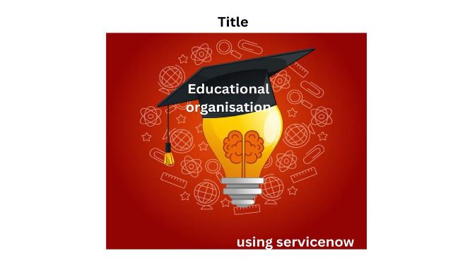 Project Title

**TEAM ID : NM2025TMID19116**

**TEAM SIZE : 4**

**TEAM LEADER : Mythili A**

**TEAM MEMBER : Nasrin banu A**

**TEAM MEMBER : Monisha M**

**TEAM MEMBER : Narmadha k**



**Problem Statement:**

The educational institution is experiencing increasing network disruptions, impacting learning, teaching, and research activities.

Current network management tools lack real-time monitoring, automation, and integration capabilities.

Manual processes delay incident detection, root cause analysis, and service restoration.

There is limited visibility into network health and asset performance across campuses.

Critical systems like LMS, student portals, and research platforms suffer from downtime. Regulatory compliance and IT governance are at risk due to inconsistent tracking and reporting.

Implementing ServiceNow Network Management will centralize operations, enhance reliability, and support digital transformation goals.

**OBJECTIVE:**

The objective of implementing ServiceNow Network Management (NM) in the educational organization is to centralize real-time monitoring of network performance across all campuses. This will help reduce network downtime by enabling proactive issue detection and automated alerts. The project aims to automate incident and change management workflows, improving response times and reducing manual effort. Advanced root cause analysis using AI-powered insights will help identify and resolve recurring issues. Integration with existing ServiceNow ITSM and CMDB systems will ensure a unified IT operations environment. The solution will also support compliance with IT policies and data governance standards. Ultimately, the project seeks to enhance user experience by ensuring reliable access to digital learning platforms, research systems, and administrative services.

**SKILLS:**



Implementing ServiceNow in an educational organization requires skills in platform configuration, especially ITSM and ITOM modules, to manage services and operations effectively. Knowledge of education-sector processes and ITIL best practices is essential for aligning workflows with academic needs. Integration expertise is needed to connect ServiceNow with campus systems like LMS, HR, and finance platforms. Strong analytical, reporting, and communication skills are also crucial for driving user adoption and continuous improvement.

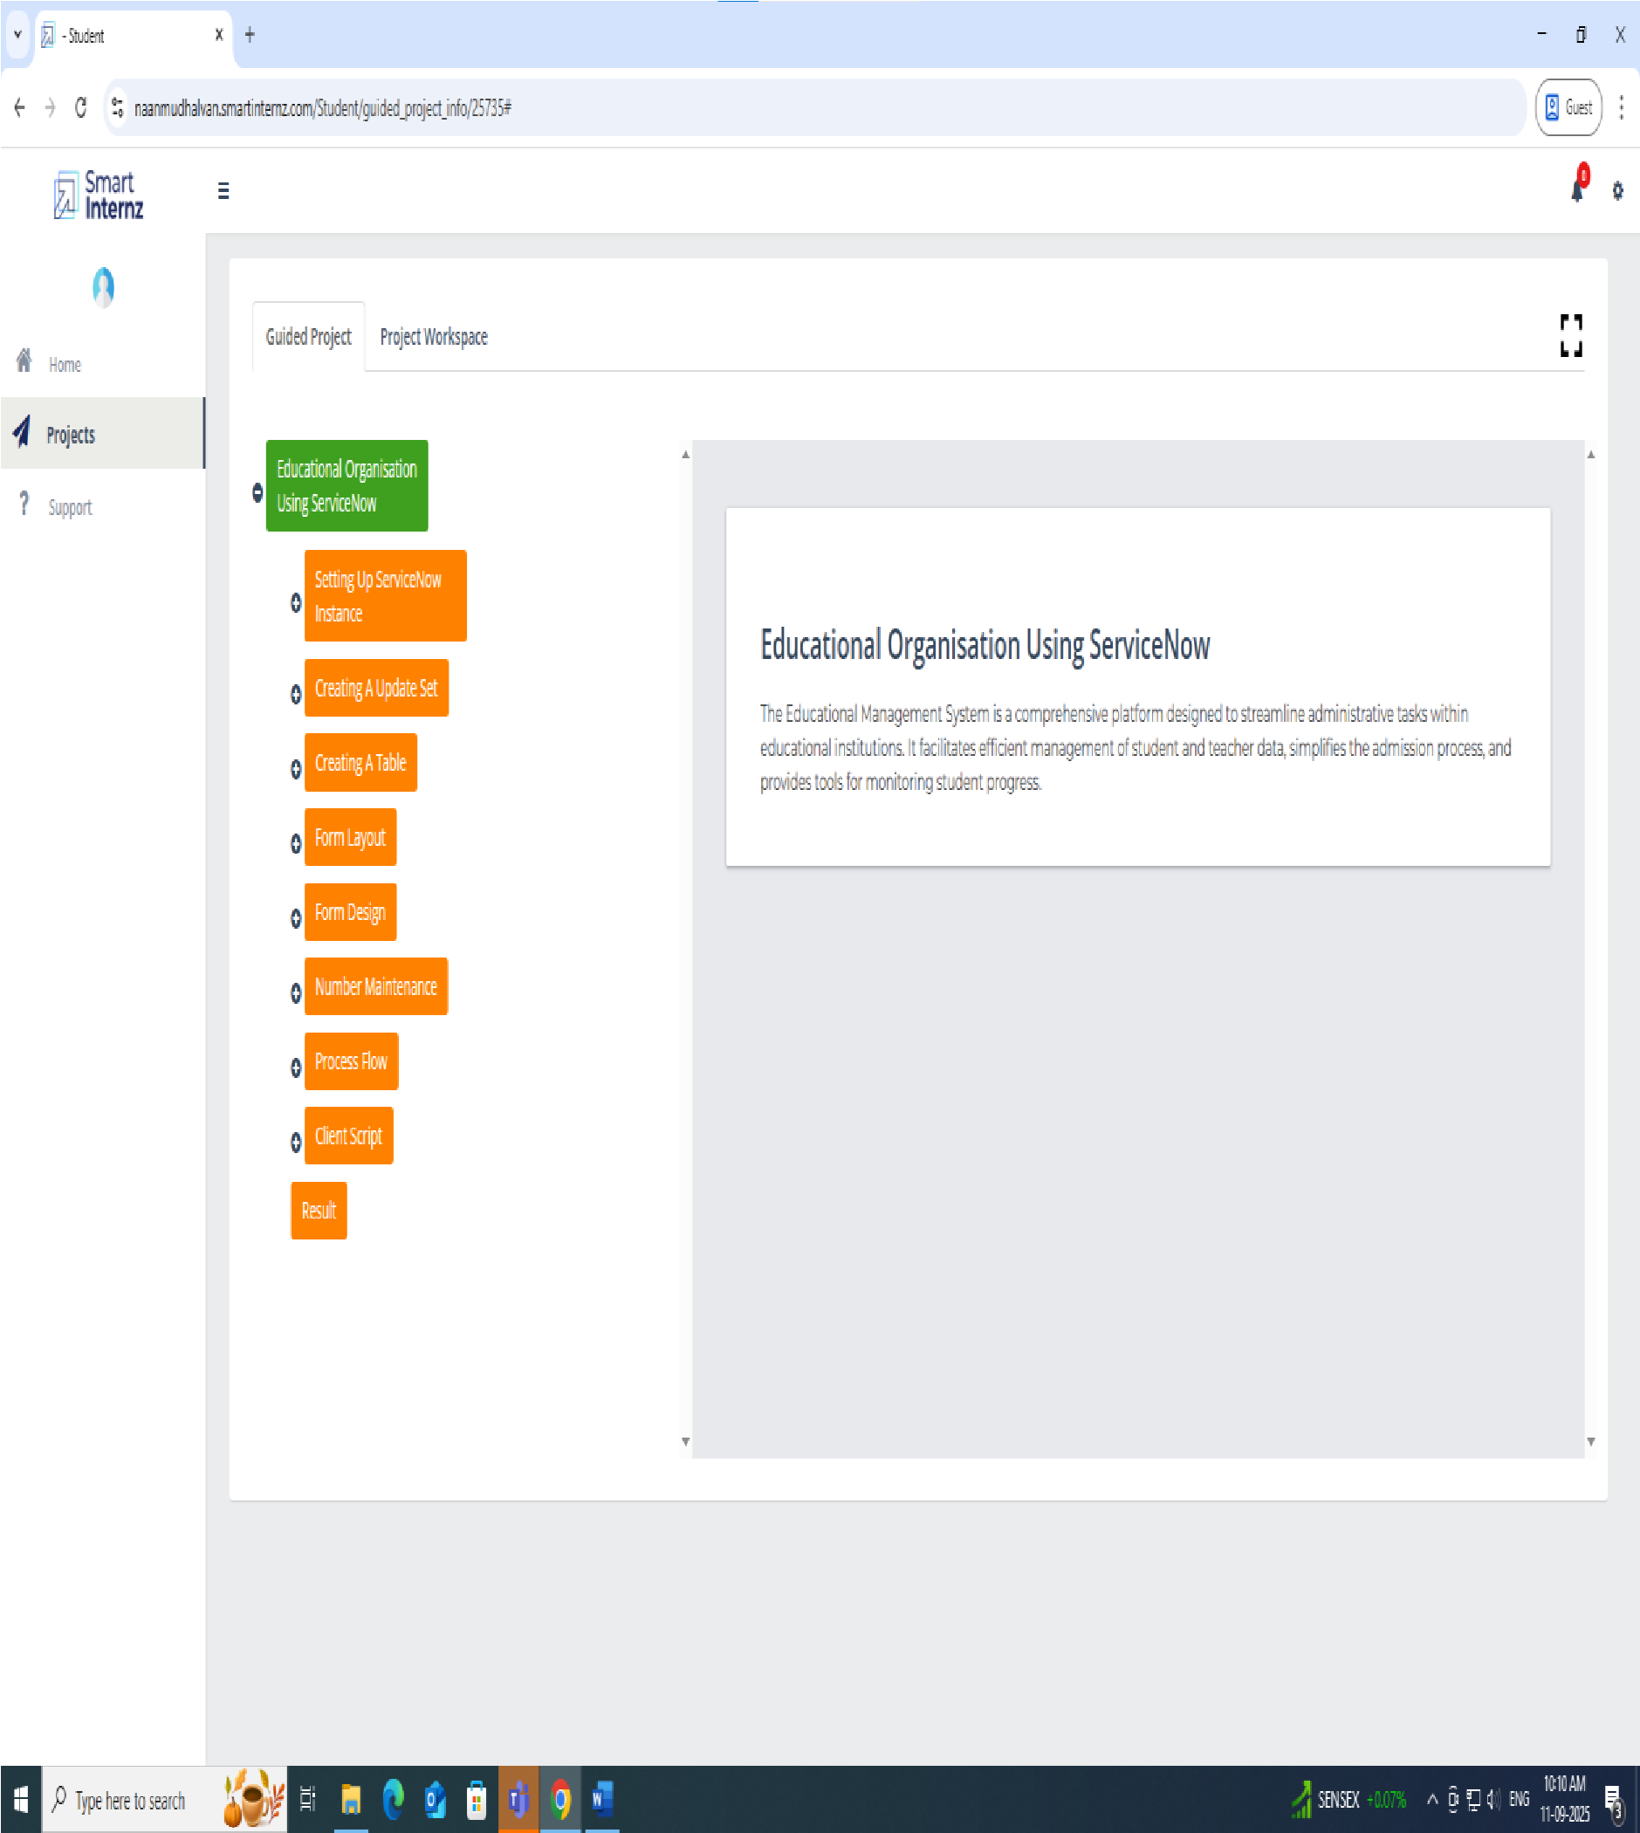

**TASK INITATION:**

**Milestone 1:** Educational Organisation Using ServiceNow

**Activity 1**: create update set

**STEPS:**

1. Click on All >> Local update sets

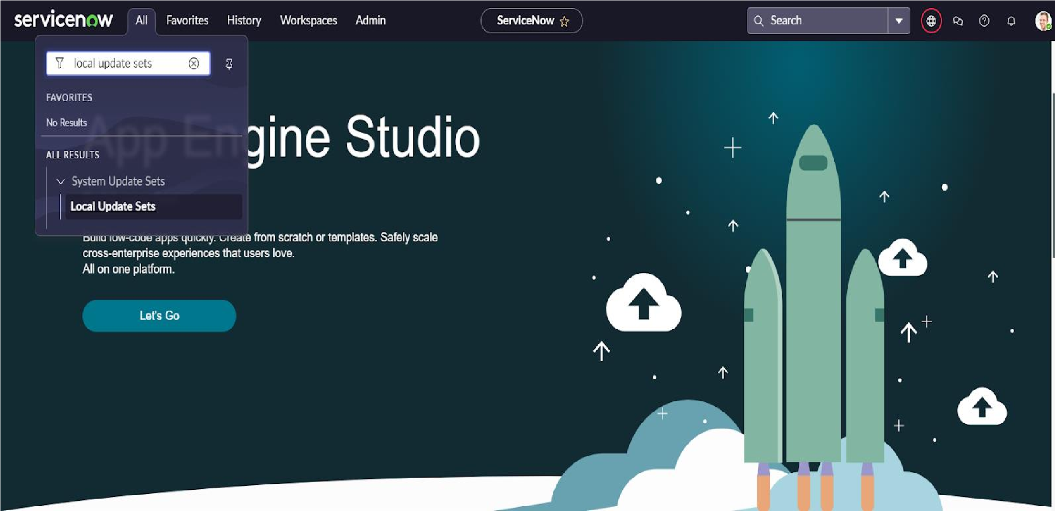

1. Click on new

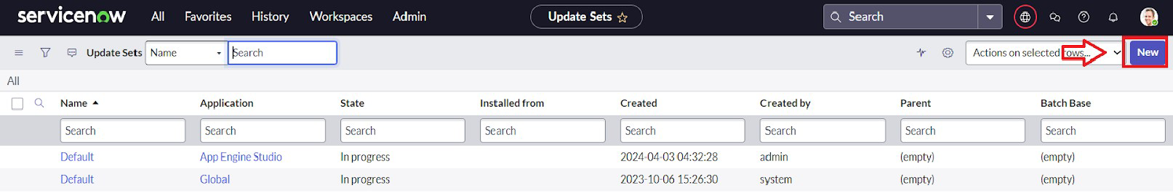

3.Enter the Details Name: Educational Organisation >> Click on Submit and make Current.

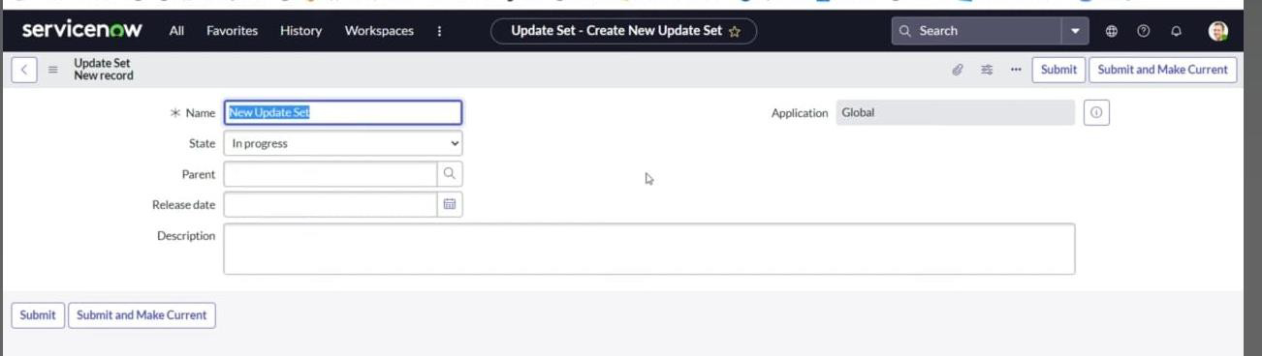

**Milestone 2**: Creating A Table.

**ACTIVITY 1:** Creating Salesforce Table.

**STEPS:**

**1**. All >> Tables.

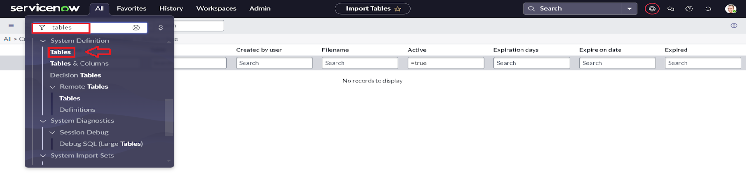

2.Click ON NEW

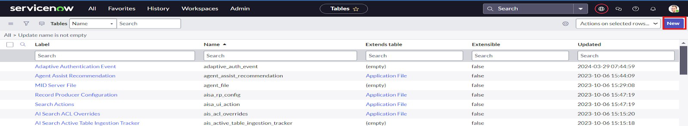

3.Enter the Label : Salesforce >> Click on Name it will Automatically generate Api name.

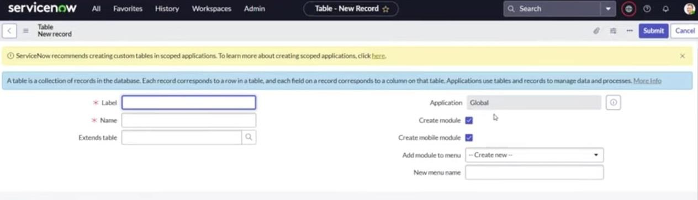

1. Create columns as given below Double Click on Column label and Enter the Column labels and click on the tick mark >> Give Type as given .

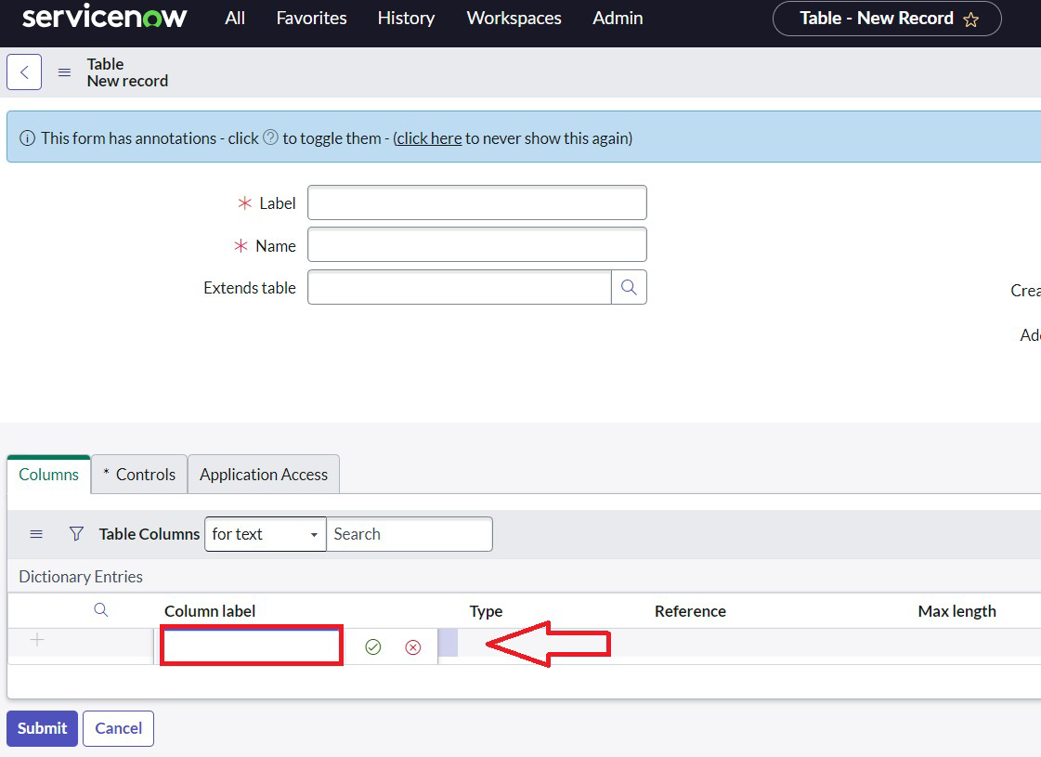

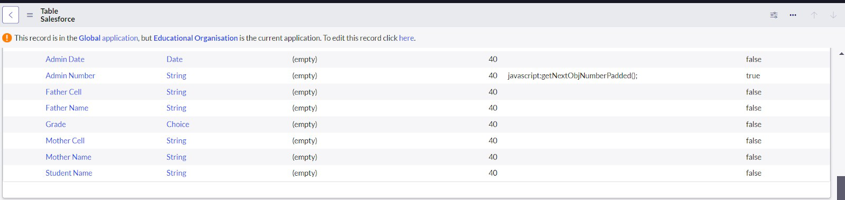

1. For “Admin Number” Give Display as True and right click on the toggle bar on top >> save. 6. Click on controls >> Enable Extensible

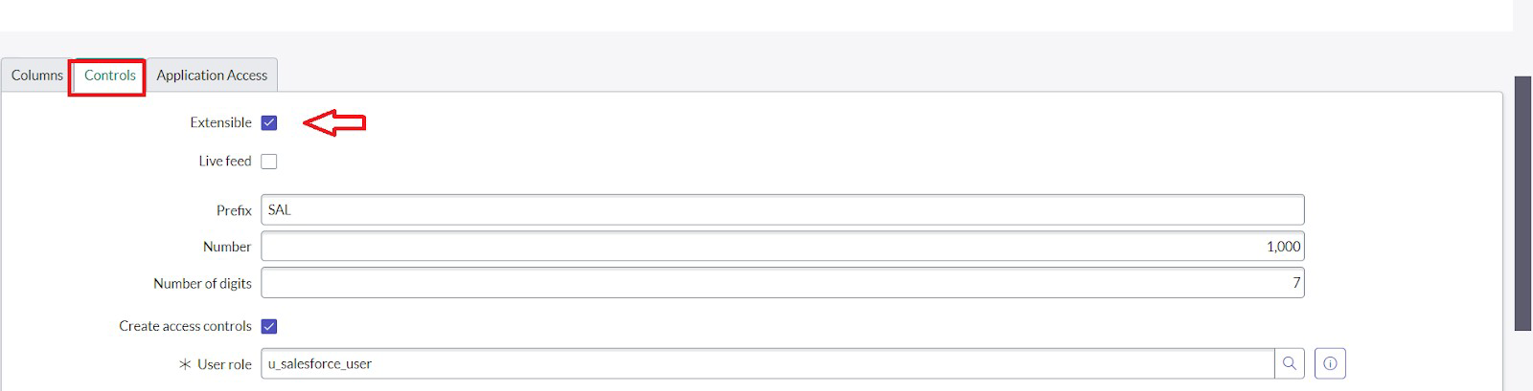

1. Click on “Admin Number” column, In Related Links Click on Advanced View >> Default View (Enable Use dynamic default) >> select Get Next Padded Number in Dynamic default value >> Update .
2. Click on “Grade” Column >> Click on Choices and give Label ,Value and Sequence as given below

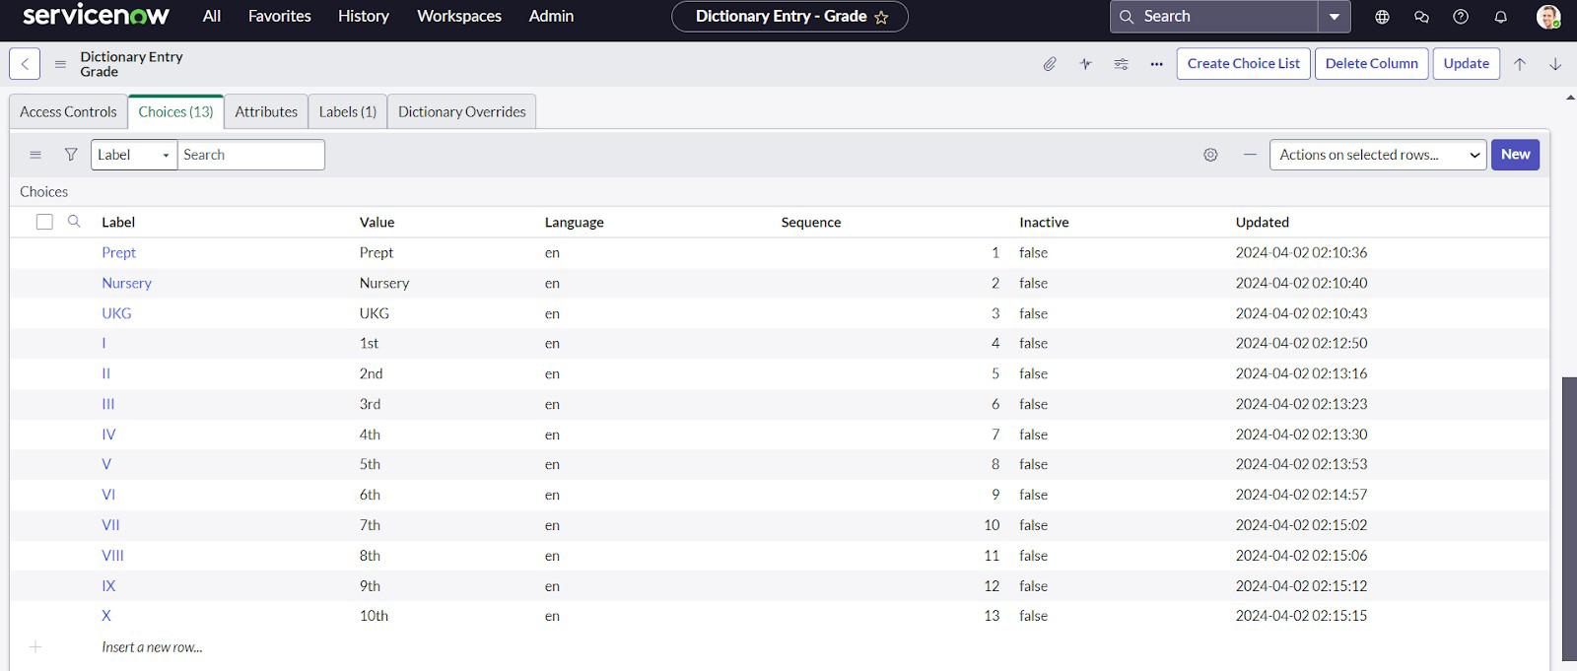

**ACTIVITY 2**: Creating Admission Table

1.Create an Admission Table with Columns given.

2.Select Extends Table >> Salesforce and also Select Add module to menu >> Salesforce. 3.Create Fields as shown

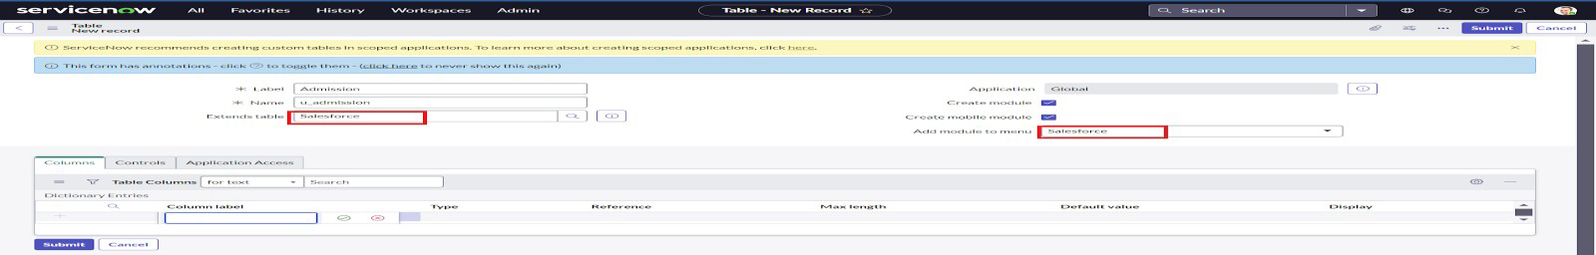

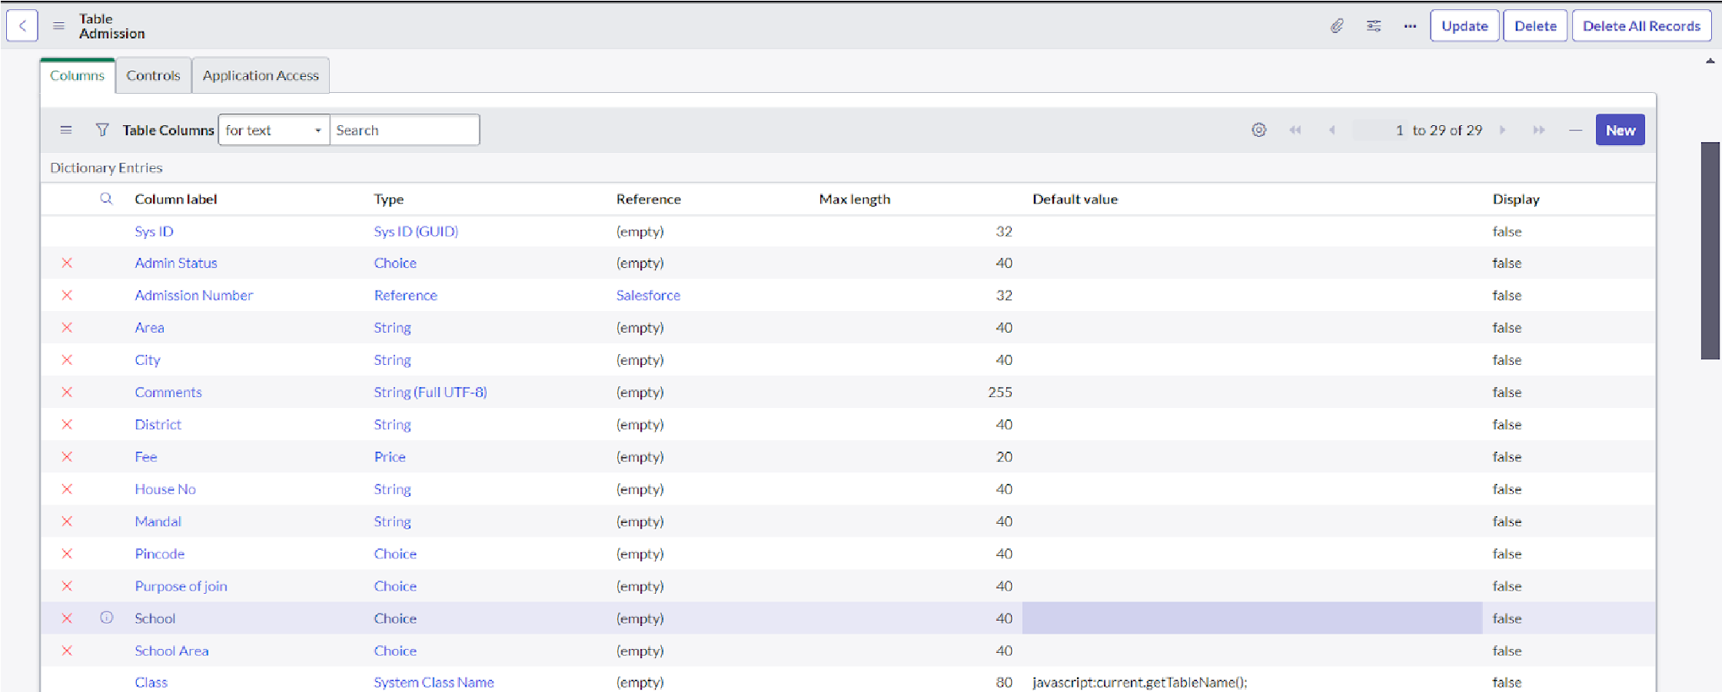

1. Create choice for Admin Status as:

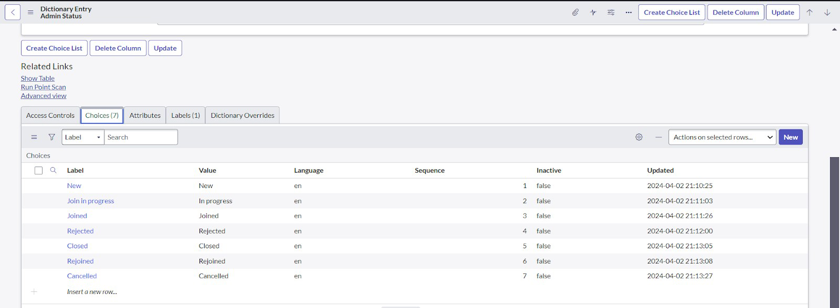

1. Create choice for Pincode as:

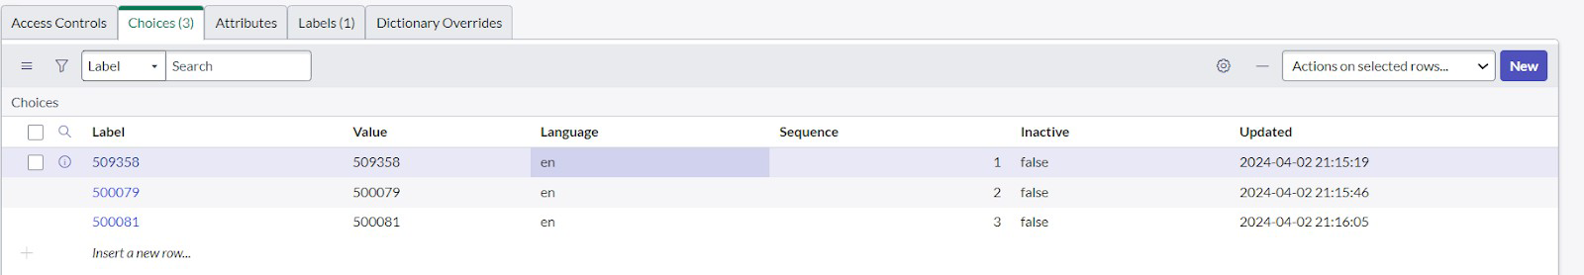

1. Create choice for Purpose of Join as:
2. Create choice for School as:
3. Create choice for School Area as:

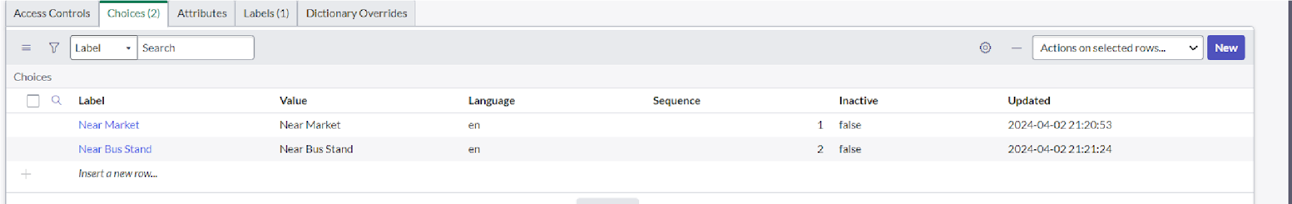

**ACTIVITY 3:** Creating Student Progress Table

**STEPS:**

1. Create a Student Progress Table with Columns given.

2.Select Add module to menu >> Salesforce.

3.Create Fields as shown:

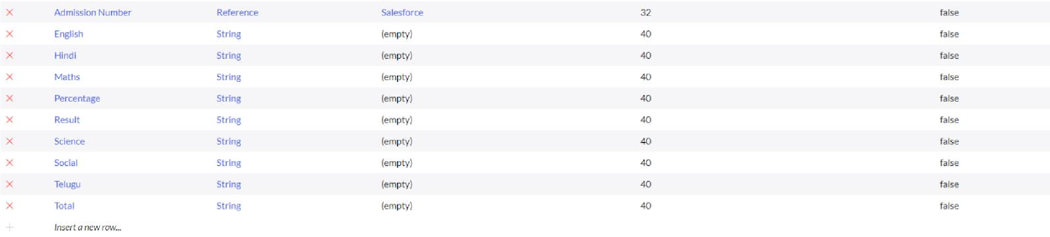

**MILESTORE 3:** FORM LAYOUT

**ACTIVITY 1**: Configuring Table form for Student Progress Table **STEPS:**

1. In the Student Progress Table Page , Click on Layout form

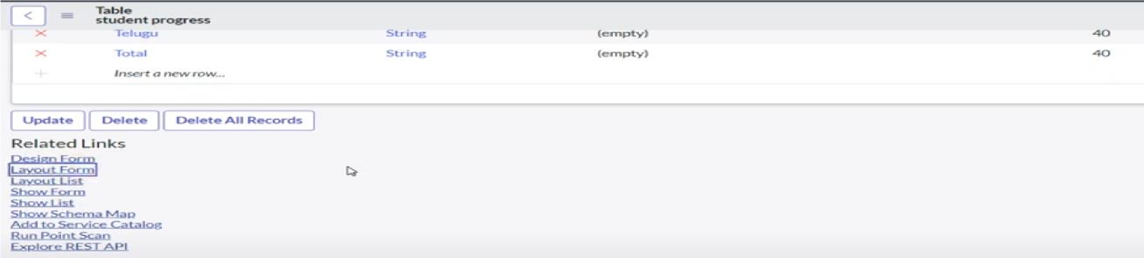

1. Click on Admission Number [+] .

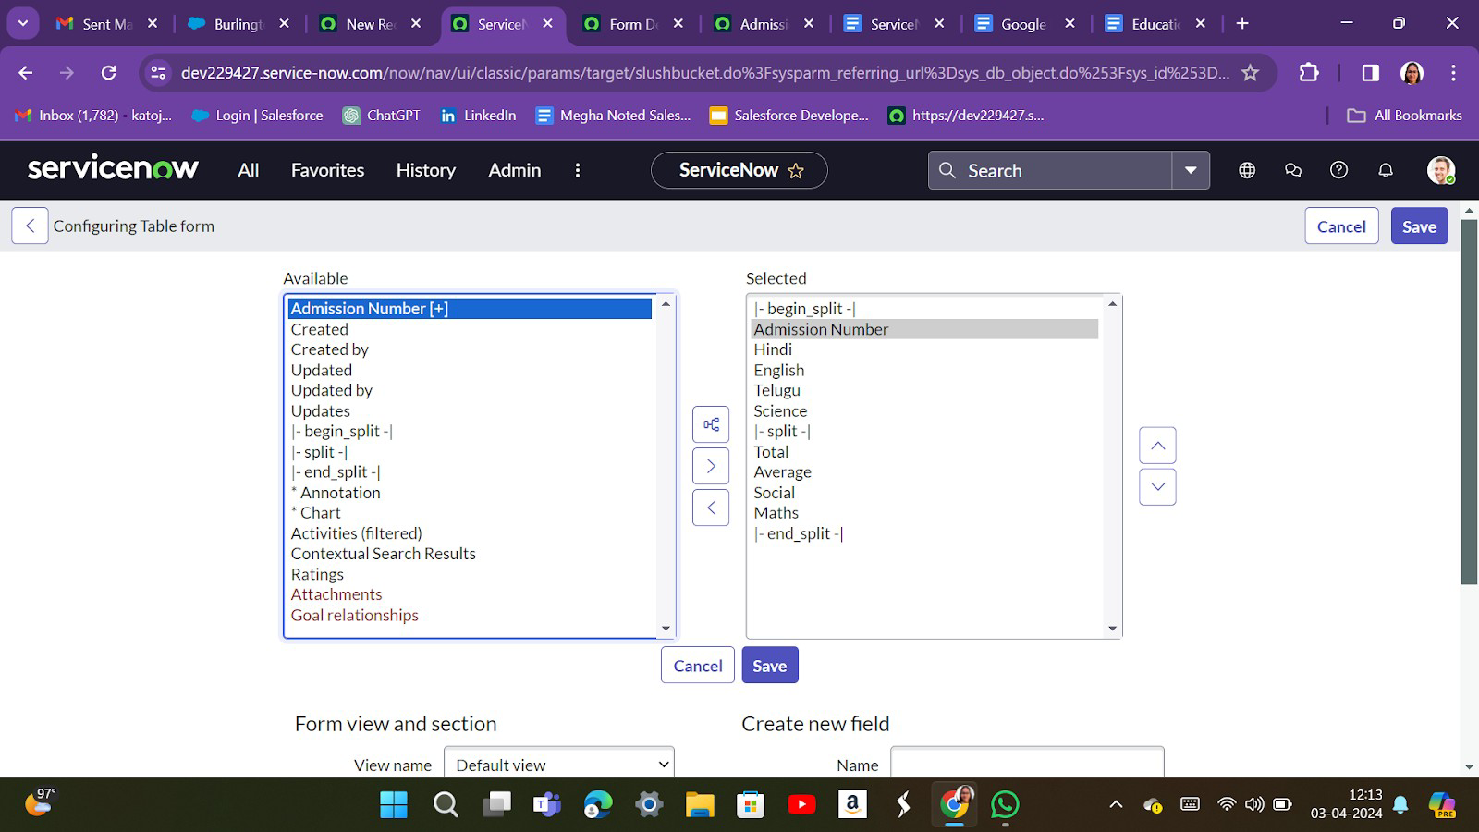

1. Select below Admission Number fields in Available side and send it to selected side as below >> save.

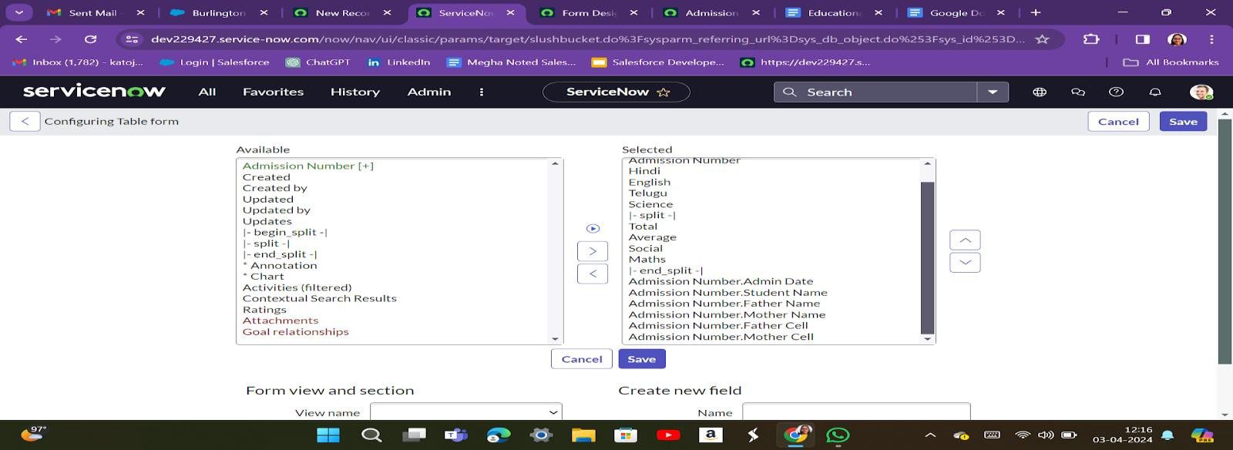

**MILESTONE 4: FORM DESIGN**

**ACTIVITY 1:** Configuring Table form for Student Progress Table

**STEPS:**

1. All >> System Definition >> Tables .

2.In Label Search for Salesforce and open

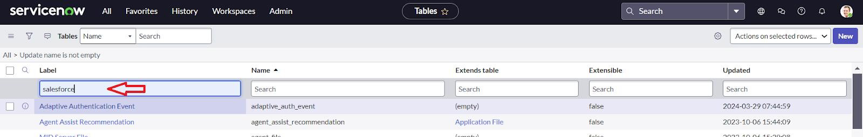

3.Right Click on top Toggle >> Configure >> Form Design.

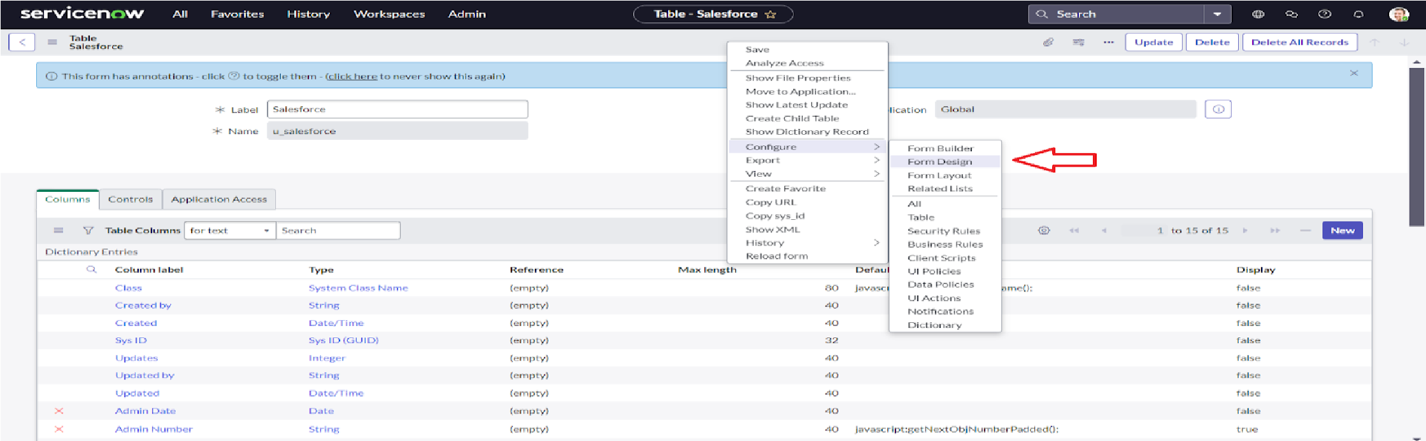

4.. In drop down select Salesforce(u_salesforce).

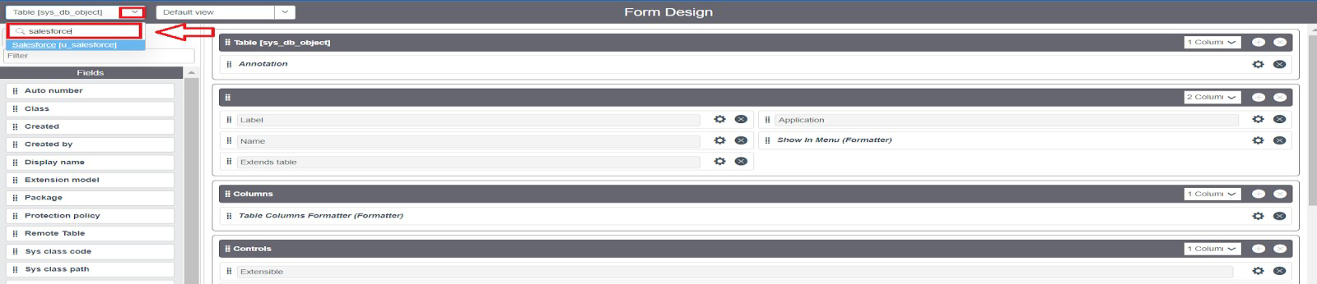

5.Drag and drop the fields to the left side as below

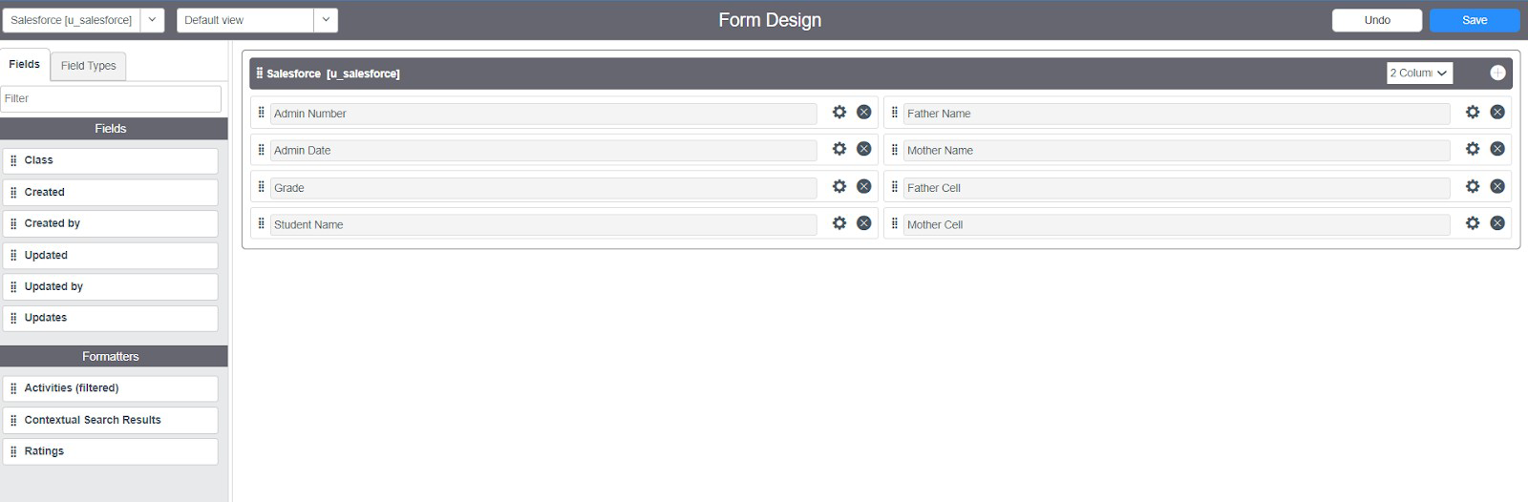

6.Save.

**ACTIVITY 2:** Creating Form Design for Admission Table

**STEPS:**

**1.**Follow the same steps as Activity1,Configure the fields as below and Save**.**

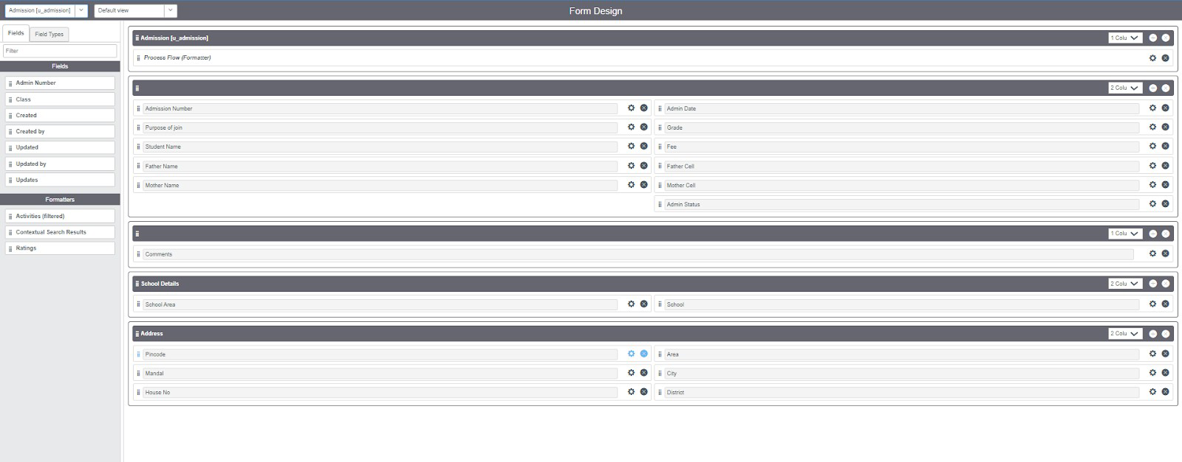

**ACTIVITY 3**: Creating Form Design for Student progress Table

**STEPS:**

1. Follow the same steps as Activity1,Configure the fields as below and Save.

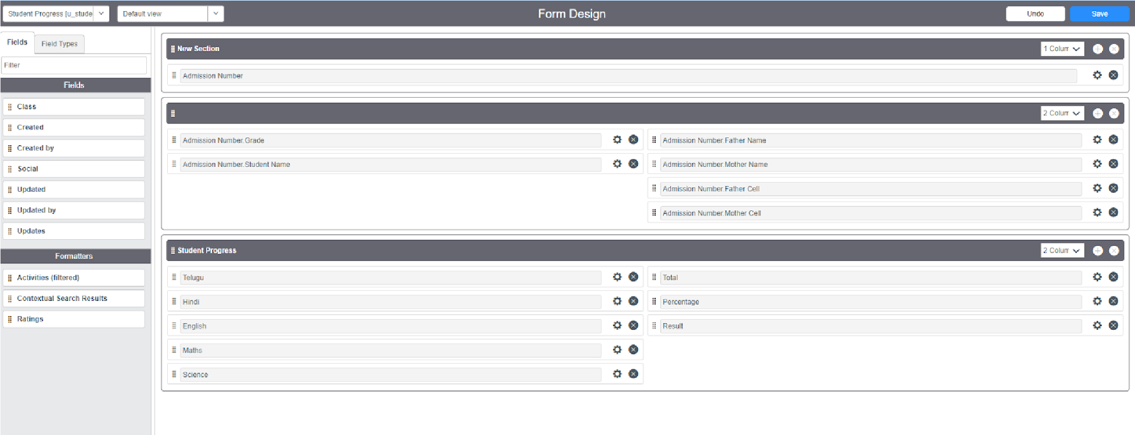

**MILESTONE 5: NUMBER MAINTENANCE**

**ACTIVITY 1:** Creating Number Maintenance for Admin Number

**STEPS:**

1. All >> Number Maintenance >> New

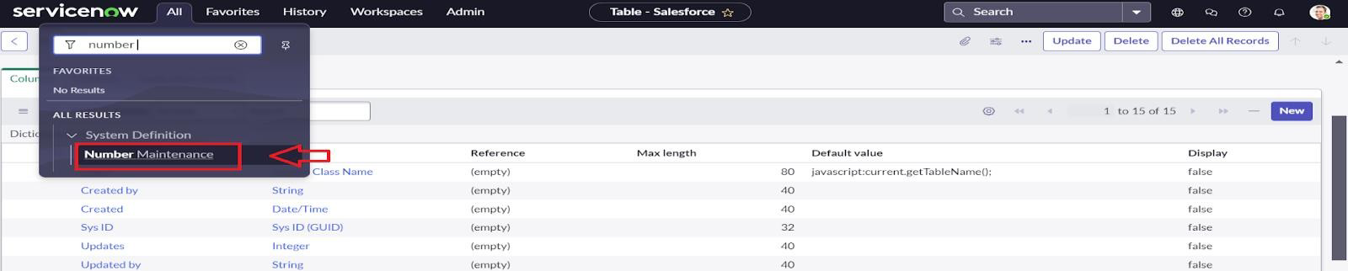

1. Fill the details >> Submit.

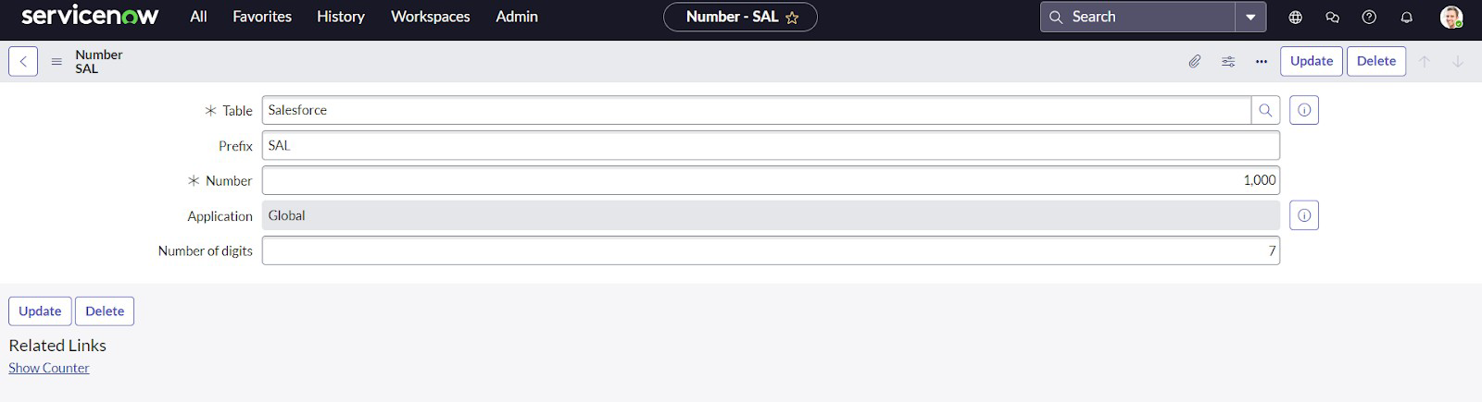

**MILESTONE 6: PROCESS FLOW**

**ACTIVITY 1: Creating Process Flow for Admission Table**

**STEPS:**

1. All >> Process Flow>> New.

2.Fill the Details as given Below

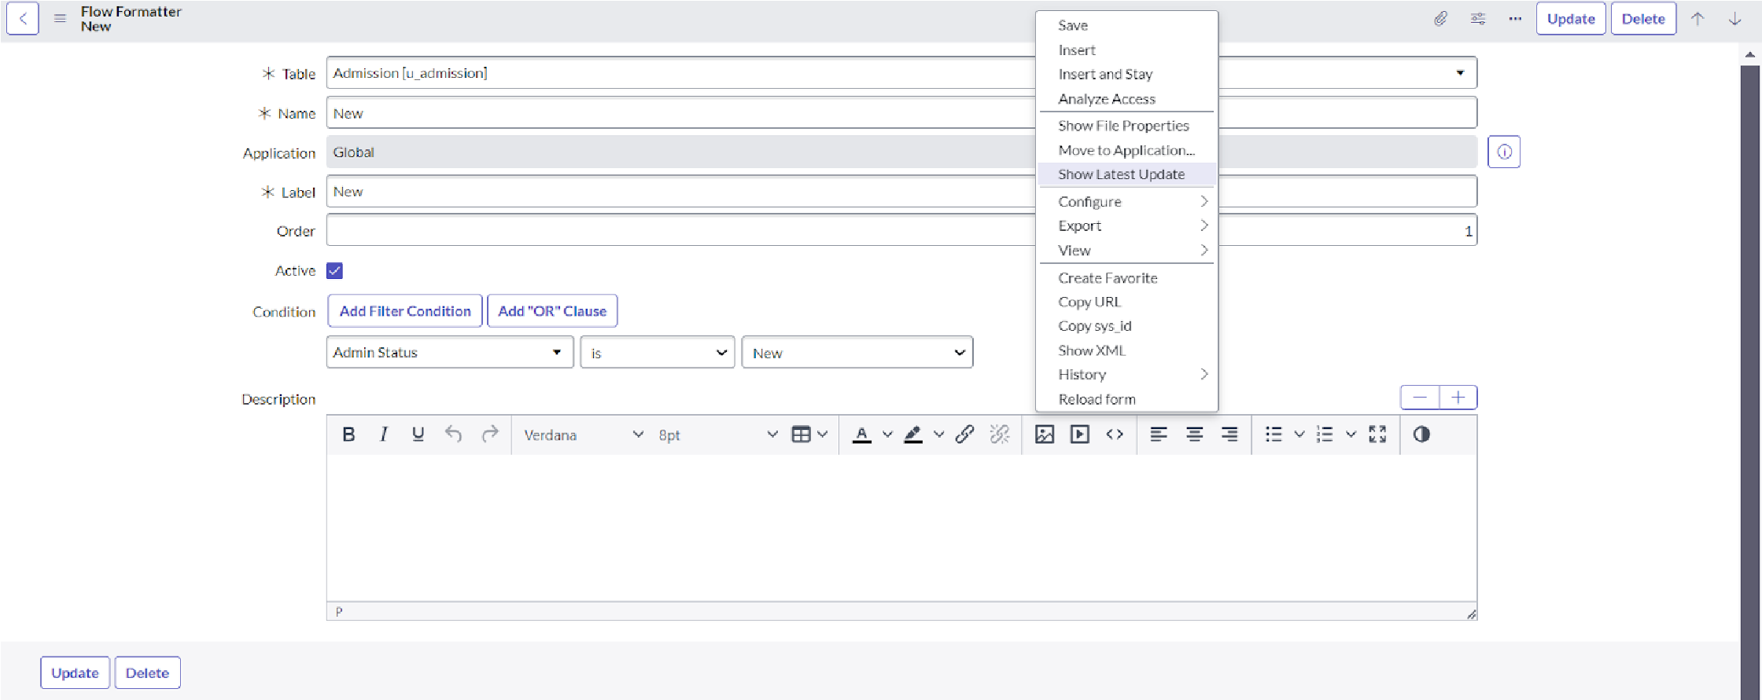

3.Right Click on toggle and click on the save .

4.Replace the Name and Label as below and click on Insert on stay.

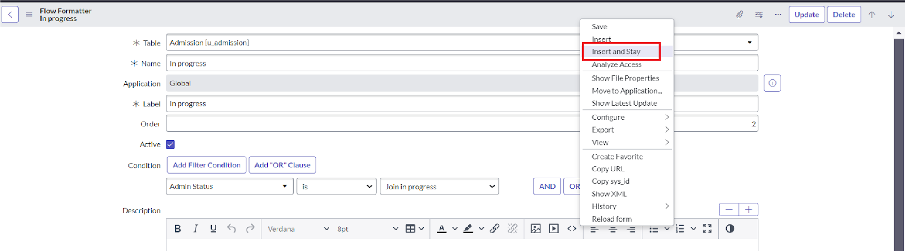

5.Replace the Name and Label in order and click on Insert on stay.

Joined >> Rejected >> Rejoined >> Closed >> Cancelled.

6.Order should be New >> InProgress >> Joined >> Rejected >> Rejoined >> Closed >> Cancelled.

**MILESTONE 7**: CLIENT SCRIPT

**ACTIVITY 1:** Creating “Auto populate” Client Scripts for Admission Table

**STEPS:**

**1**. All >> Client Scripts >> New.

2.Fill the Details as given.

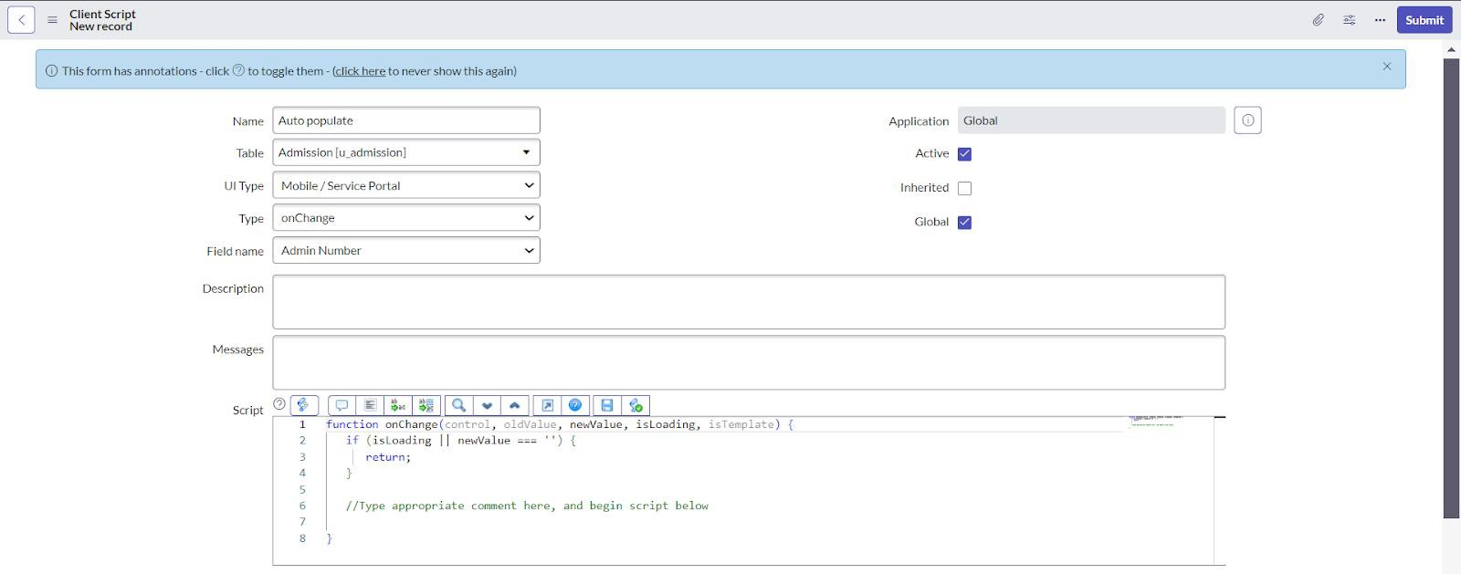

3. Write the Code as below, Enable Isolate script and Save.

function onChange(control, oldValue, newValue, isLoading, isTemplate) { if (isLoading || newValue === '') {

return;

}

//Type appropriate comment here, and begin script below var a = g_form.getReference('u_admission_number'); g_form.setValue('u_admin_date',a.u_admin_date); g_form.setValue('u_grade',a.u_grade); g_form.setValue('u_student_name',a.u_student_name); g_form.setValue('u_father_name',a.u_father_name); g_form.setValue('u_mother_name',a.u_mother_name); g_form.setValue('u_father_cell',a.u_father_cell);

g_form.setValue('u_mother_cell',a.u_mother_cell);

g_form.setDisabled('u_admin_date',a.u_admin_date); g_form.setDisabled('u_grade',a.u_grade); g_form.setDisabled('u_student_name',a.u_student_name); g_form.setDisabled('u_father_name',a.u_father_name); g_form.setDisabled('u_mother_name',a.u_mother_name); g_form.setDisabled('u_father_cell',a.u_father_cell);

g_form.setDisabled('u_mother_cell',a.u_mother_cell);

}

**Note**: Make sure the Field names should be the same as you created .

**ACTIVITY 2:** Creating “Pincode Update” Client Scripts for Admission Table

**STEPS:**

1.Fill the Details as given.

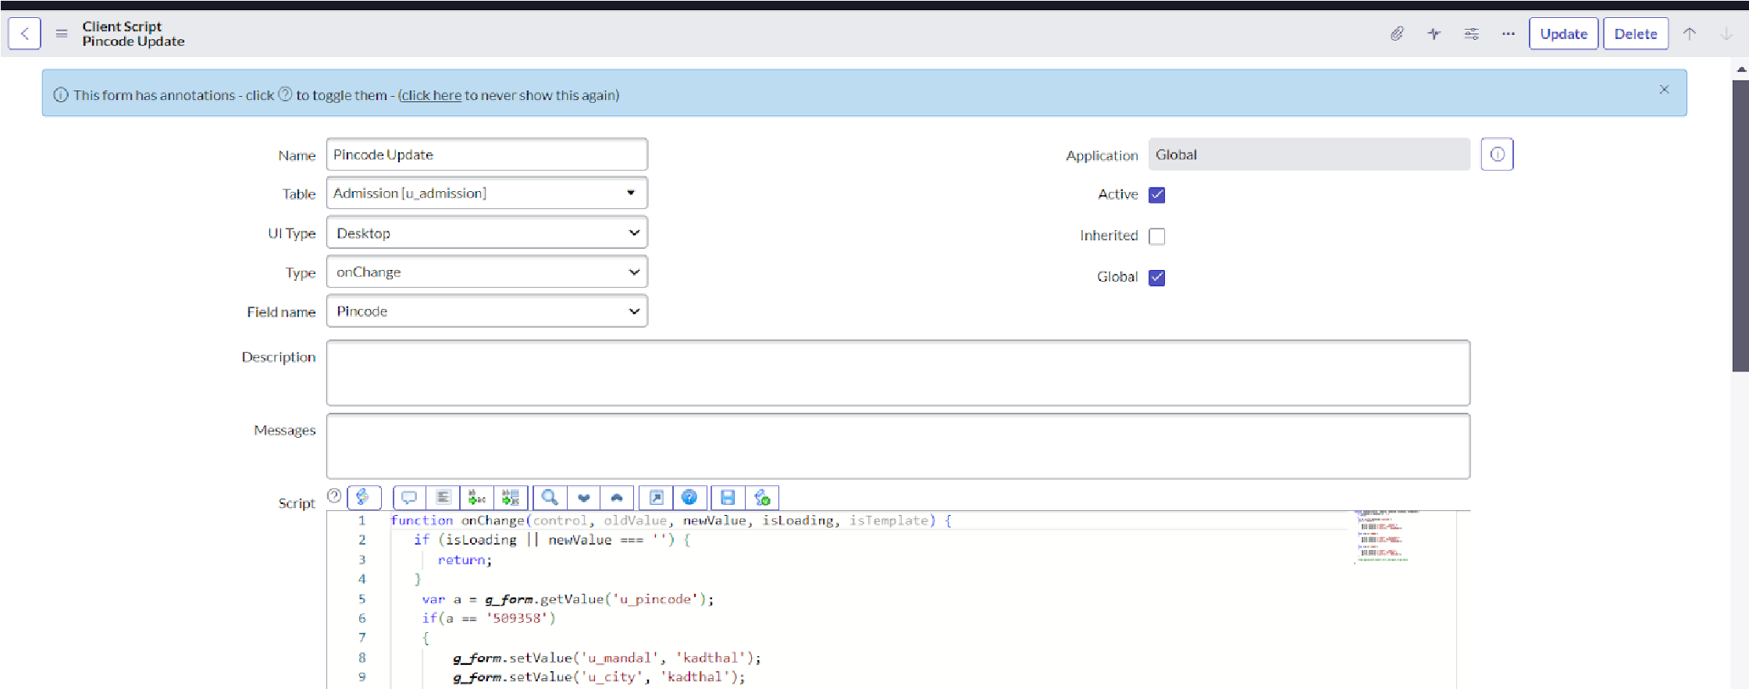

2. Write the Code as below, Enable Isolate script and Save.

function onChange(control, oldValue, newValue, isLoading, isTemplate) { if (isLoading || newValue === '') { return;

}

var a = g_form.getValue('u_pincode'); if(a == '509358')

{

g_form.setValue('u_mandal', 'kadthal'); g_form.setValue('u_city', 'kadthal'); g_form.setValue('u_district', 'RangaReddy');

}

else if(a == '500081')

{

g_form.setValue('u_mandal', 'karmanghat'); g_form.setValue('u_city', 'karmanghat'); g_form.setValue('u_district', 'RangaReddy');

}

else if(a == '500079') { g_form.setValue('u_mandal', 'Abids'); g_form.setValue('u_city', 'AsifNagar');

g_form.setValue('u_district', 'Hyderabad');

}

//Type appropriate comment here, and begin script below

}

**ACTIVITY 3**: Creating “Disable Fields” Client Scripts for Student progress Table

**STEPS:**

1.Fill the Details as given

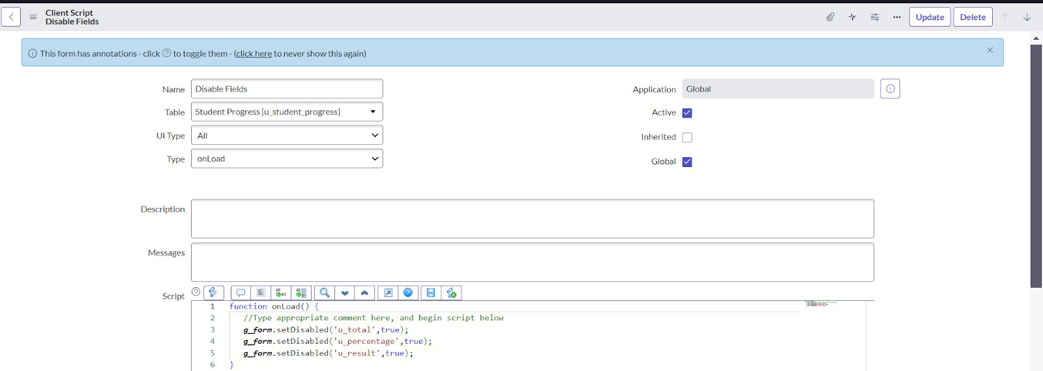

3.Write the Code as below, Enable Isolate script and Save.

function onLoad() {

//Type appropriate comment here, and begin script below g_form.setDisabled('u_total',true); g_form.setDisabled('u_percentage',true); g_form.setDisabled('u_result',true);

}

**ACTIVITY 4**: Creating “Total Update” Client Scripts for Student progress Table

**STEPS**

1. Fill the Details as given.

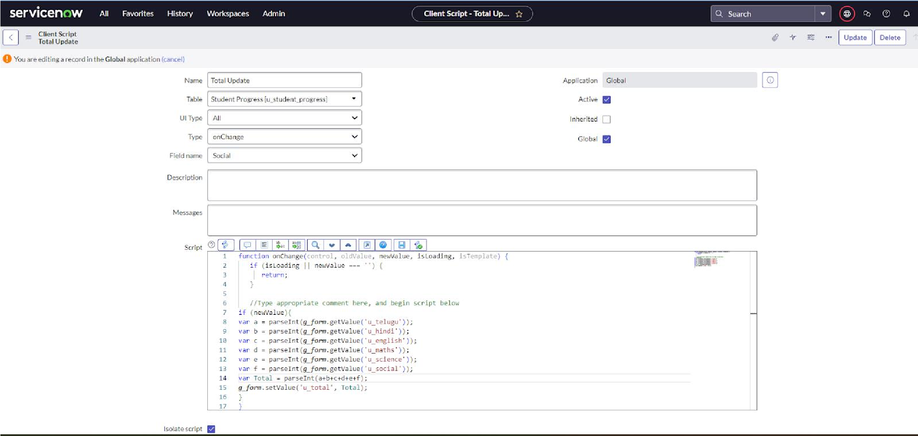

4.Write the Code as below, Enable Isolate script and Save.

function onChange(control, oldValue, newValue, isLoading, isTemplate) { if (isLoading || newValue === '') { return;

}

//Type appropriate comment here, and begin script below if (newValue){

var a = parseInt(g_form.getValue('u_telugu')); var b = parseInt(g_form.getValue('u_hindi')); var c = parseInt(g_form.getValue('u_english')); var d = parseInt(g_form.getValue('u_maths')); var e = parseInt(g_form.getValue('u_science')); var f = parseInt(g_form.getValue('u_social')); var Total = parseInt(a+b+c+d+e+f); g_form.setValue('u_total', Total);

}

}

**ACTIVITY 5:**

**STEPS:**

**1**.Creating “Result” Client Scripts for Student progress Table

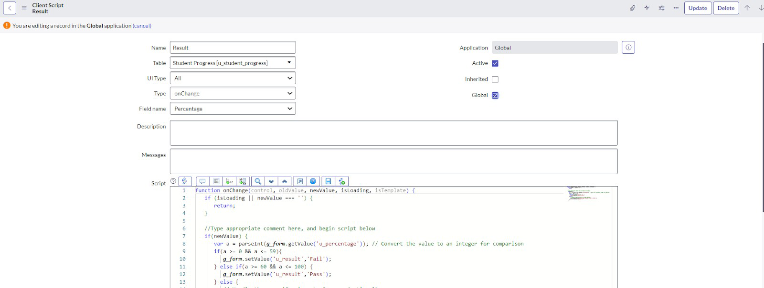

3. Write the Code as below, Enable Isolate script and Save.

function onChange(control, oldValue, newValue, isLoading, isTemplate) { if (isLoading || newValue === '') { return; }

//Type appropriate comment here, and begin script below if(newValue) {

var a = parseInt(g_form.getValue('u_percentage')); // Convert the value to an integer for comparison if(a >= 0 && a <= 59){

g_form.setValue('u_result','Fail'); } else if(a >= 60 && a <= 100) {

g_form.setValue('u_result','Pass');

} else {

// Handle the case if a is out of range (optional)

g_form.addErrorMessage('Percentage should be between 0 and 100.'); g_form.clearValue('u_result');

}

}

}

**ACTIVITY 6:** Creating “Percentage” Client Scripts for Student progress Table

**STEPS:**

1. Fill the Details as given.

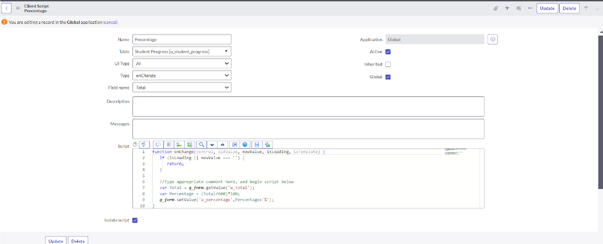

2.Write the Code as below, Enable Isolate script and Save.

function onChange(control, oldValue, newValue, isLoading, isTemplate) { if (isLoading || newValue === '') { return;

}

//Type appropriate comment here, and begin script below

var Total = g_form.getValue('u_total'); var Percentage = (Total/600)*100;

g_form.setValue('u_percentage',Percentage+'%');

}

**MILESTONE 8: RESULT**

**1.**

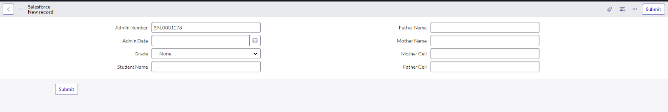

**2.**

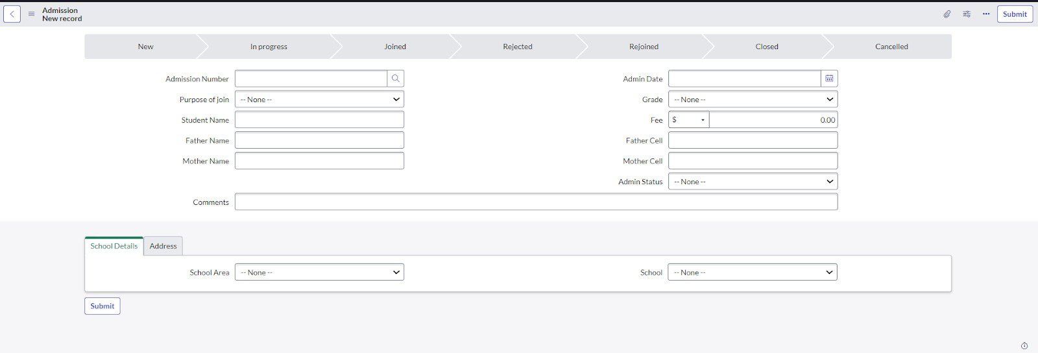

**3.**

